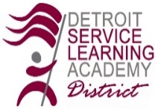

DETROIT SERVICE LEARNING ACADEMY
ANNUAL BOARD MEETING
Board of Directors Meeting Agenda
Tuesday, May 19, 2026 at 5:00 pm
ACTION ITEMS
- APPROVAL of Tuesday, May 19, 2026 Agenda
- APPROVAL of Saturday, April 25, 2026 Proposed Board Meeting Minutes
- REVIEW of Financial Report
- APPROVAL of Spring Policy Update

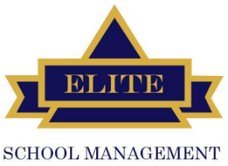



NEXT MEETING
Tuesday, June 23, 2026
Regular Board Meeting

- CALL TO ORDER
- ROLL CALL
- Approval of Tuesday, May 19, 2026 Agenda
- Approval of Saturday, April 25, 2026 Proposed Board Meeting Minutes
- FINANCIAL REPORT
  - April Financial Report
- MANAGEMENT REPORTS – Maurice Evans
  - The Children’s Center
  - Compliance & Academics - Update
  - Building & Operations Report - Update
  - Human Resources - Update
  - Early Childhood - Update
  - Elite Training Institute – Update
  - Security – Update

- COMMENTS BY AUTHORIZER

- REAUTHORIZATION PROCESS UPDATE

- BOARD MATTERS

- PUBLIC COMMENT
- ADJOURNMENT
Public Comment:
During the Zoom meeting: 1. Click Chat in the meeting controls. 2. This will open the chat on the right. You can type a message into the chat box or click on the drop down next to that include: Your name, address and, affiliation along with the comment/concern. The Board welcomes comments from the public and values the input our stakeholders bring to the table. The President respectfully reminds all of us, this is not a forum for debate. The Board may choose to ask clarifying questions regarding expressed concern, but will not respond to the concern at the meeting. You can expect a timely response from the appropriate individual(s). Personnel matters cannot and will not be discussed in this forum.

